Meat Raffles

Russells in Annadale, MN

Fridays in December

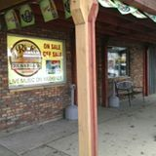

Flinstones Clearwater, MN

Fridays in October

